Name: |  |  | Class: |  |  | Date:

Vocabulary
 |  | 1 | Write the right words in the crossword puzzle.
 |  |  | Schreibe die richtigen Wörter in das Kreuzworträtsel.

1.  2.  3.  4.  5.  6. | Luke’s mum: “Oh no, Luke.  Your room is a … (Unordnung)!”  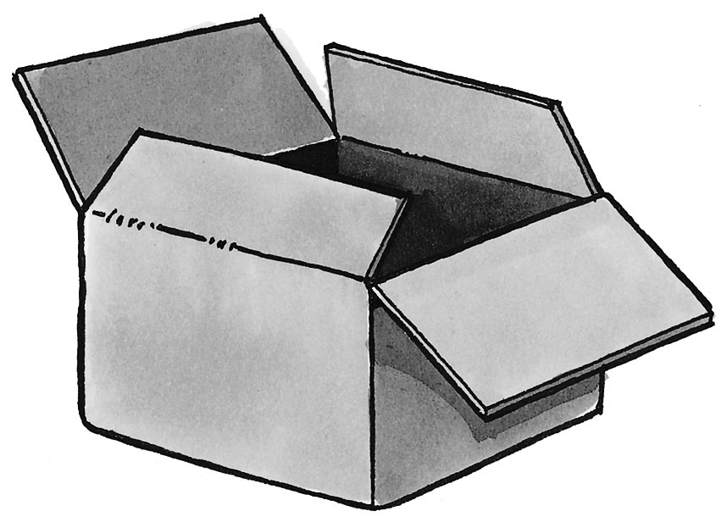  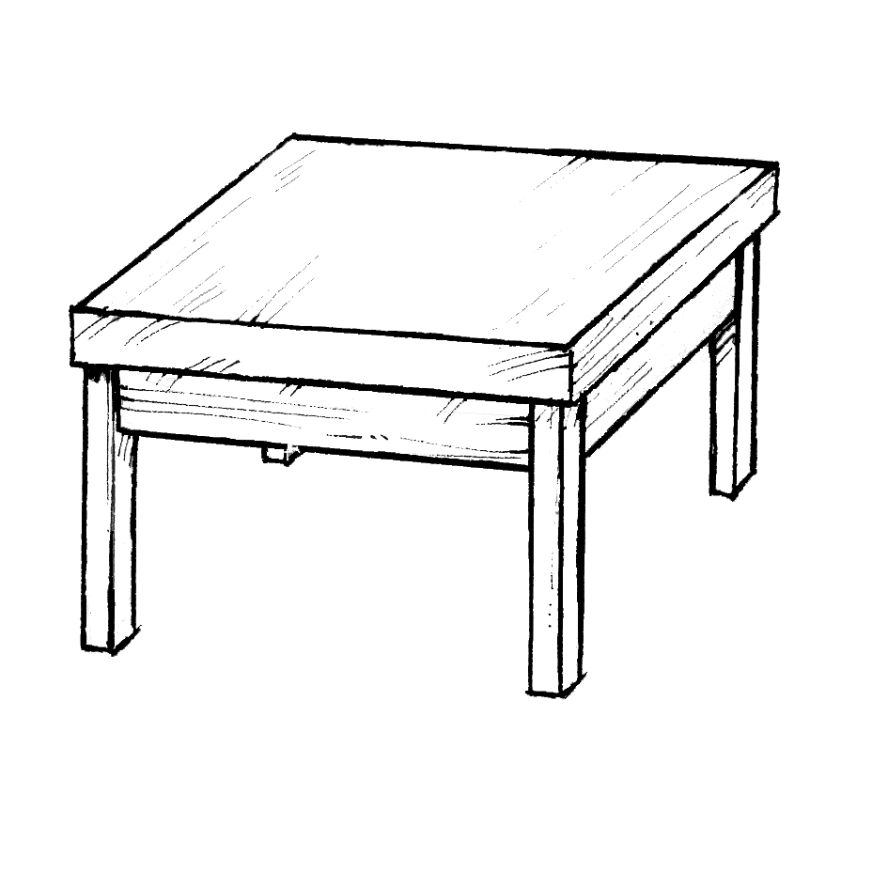  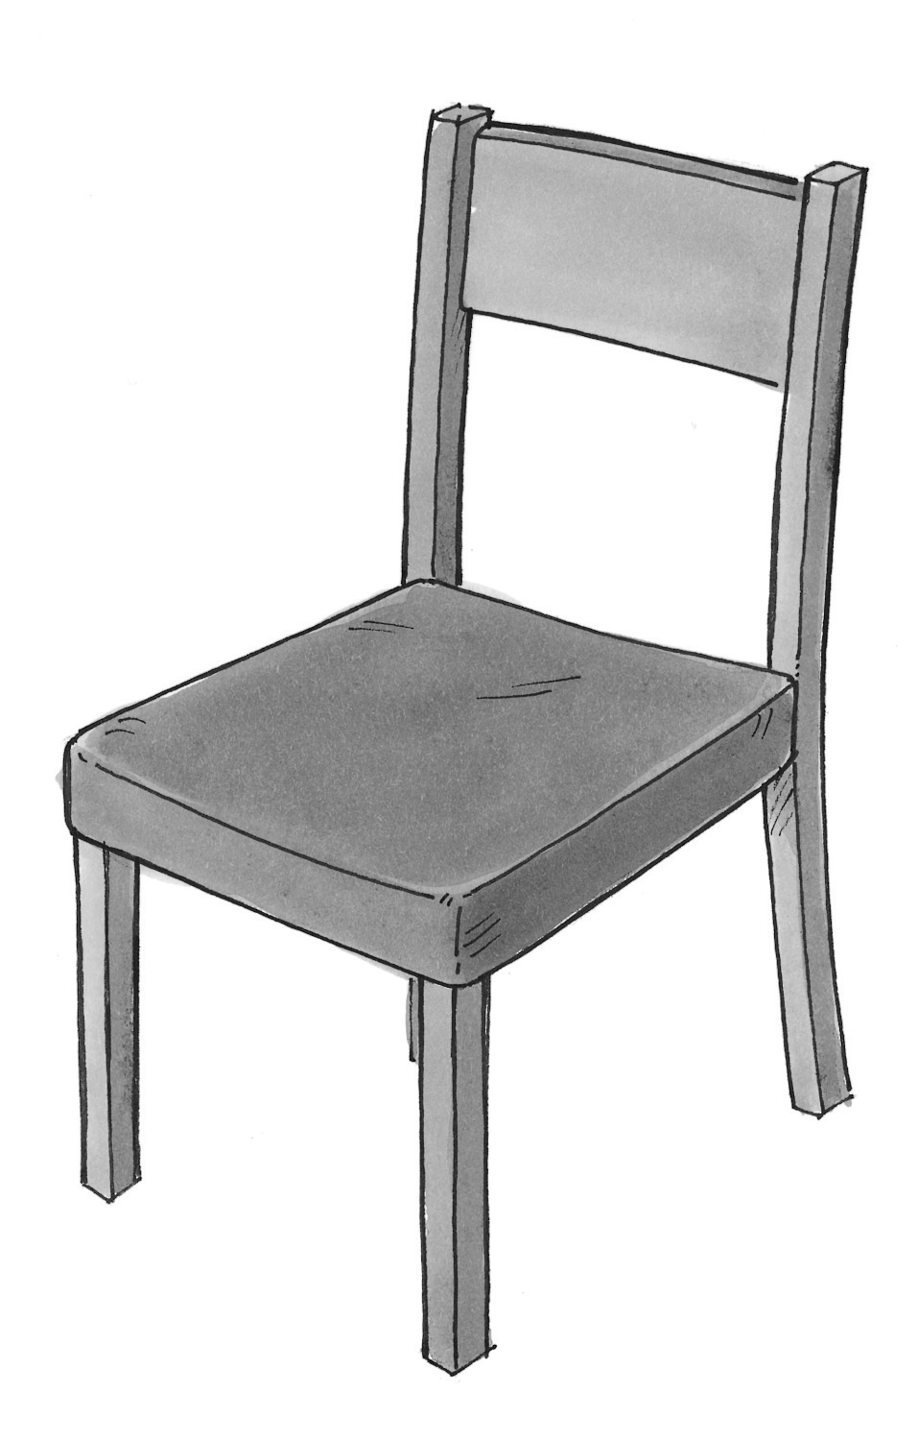  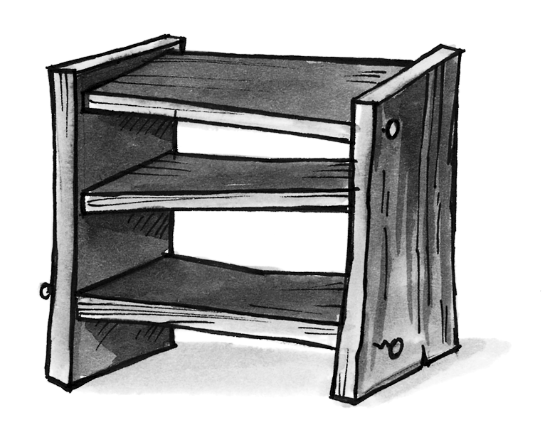  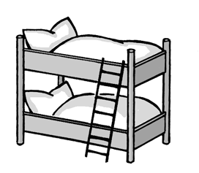 |  |  |  |  | 4.   | 5.  
1.  2.  3.  4.  5.  6. |  |  |  |  | 3.   | 4.   | 5.  
1.  2.  3.  4.  5.  6. |  |  |  | 2.   | 3.   |  |  | 6.  
1.  2.  3.  4.  5.  6. |  |  | 1.   | 2.   |  |  |  | 6.  
1.  2.  3.  4.  5.  6. |  | 
/ 6

 |  | 2 | Look at each line. Find the wrong word and cross it out. There is one example.
 |  |  | Schau dir jede Zeile an. Finde das falsche Wort und streiche es durch. Es gibt ein Beispiel.
Example: England  Germany  Greenwich  London
1. red  white  nice  blue
2. in  is  on  under
3. I  he  they  the
4. sister  boy  father  brother
5. who  where  what  with
6. pet  T-shirt  poster  mobile phone
/ 6

 |  | 3 | Where is Ben? Look at the pictures and complete the sentences.
 |  |  | Wo ist Ben? Schau dir die Bilder an und ergänze die Sätze.
in
on
under
next to

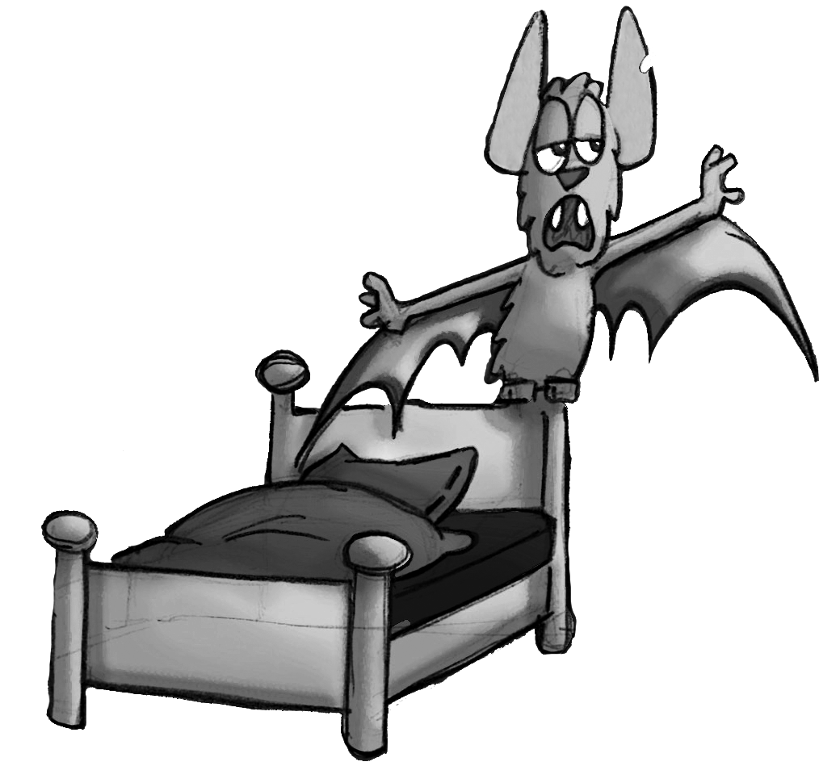 |  | 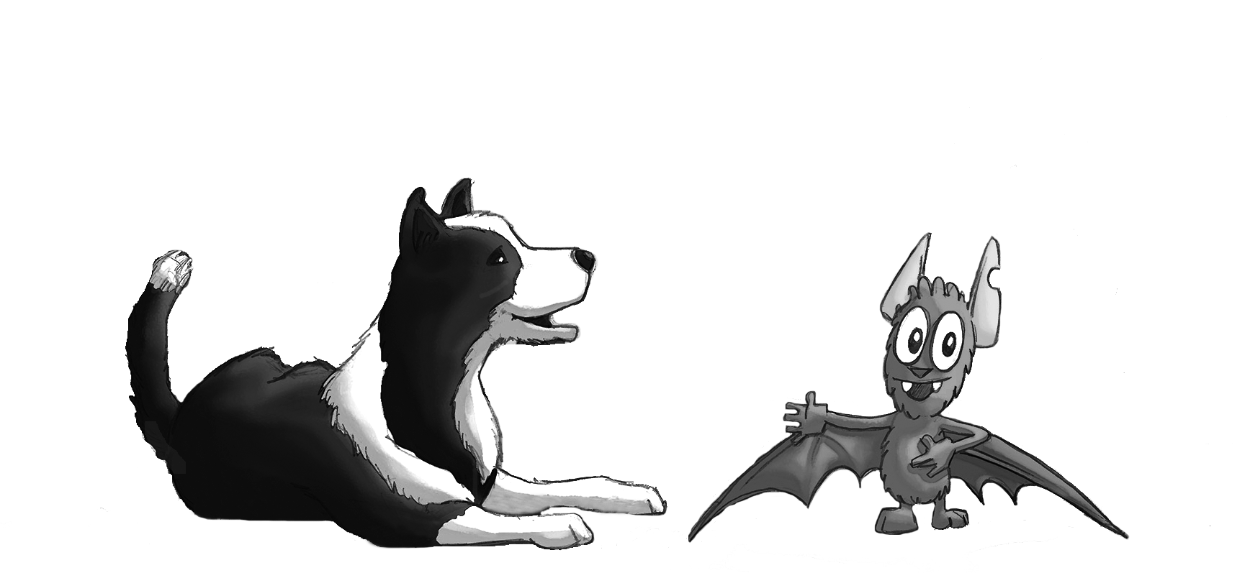
1. Ben is . |  | 3. Ben is .
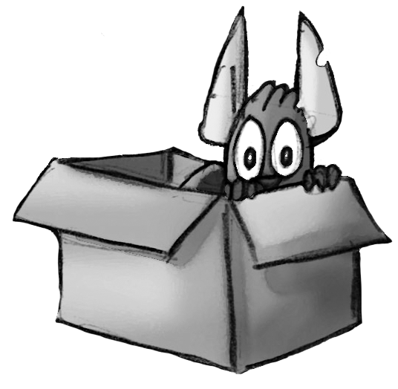 |  | 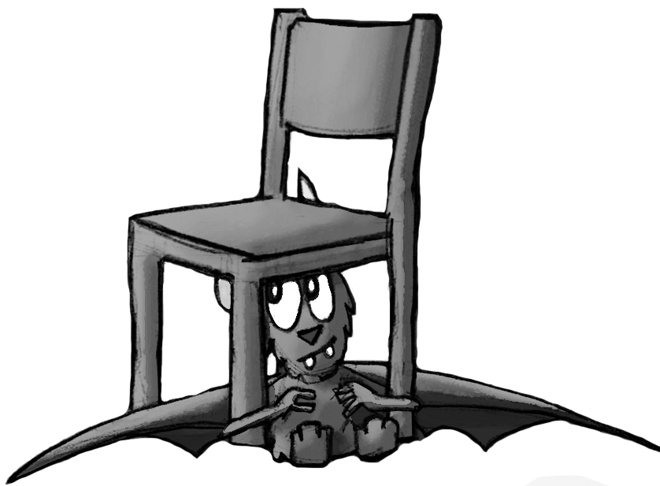
2. Ben is . |  | 4. Ben is .
/ 4

 |  | 4 | What’s in Luke’s room? Complete the sentences.
 |  |  | Was ist in Lukes Zimmer? Ergänze die Sätze.
carpet
lamps
alarm clock
wardrobe
trainers

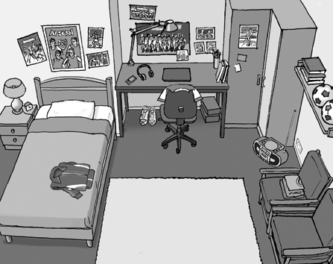 |  | There are two in Luke’s room, one is on his table and one is next to his bed. Luke’s new are under the table. One of Luke’s posters is on the . The is next to the bed and next to the chairs. Luke: “Where is my . ? Oh no, I’m late!”
/ 5
Grammar
 |  | 5 | Put in the right plural form. There is one example.
 |  |  | Setze die richtige Pluralform (Mehrzahl) ein. Es gibt ein Beispiel.

Example: There are three books (book) on the shelf.
1. There are three (mobile) on the table.
2. There are two (box) under the table.
3. Are the (dog) in the garden or in the park?
4. There are two English (family) in this photo.
5. There are two (shelf) in my room.
6. Ben: “I can’t find my new (T-shirt). Where are they?”
/ 6
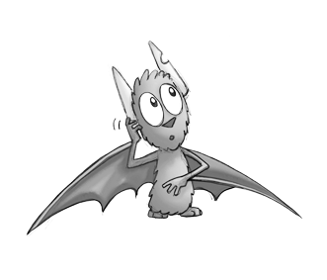

 |  | 6 | Put in the right form.
 |  |  | Setze die richtige Form ein.
 |  |  | There is  There are |  | 1. ten books on the table.  2. one red chair next to the table.  3. one green box under the bed.  4. two T-shirts on the bed.  5. one crazy poster in my room.  6. three cats in the garden.
/ 6

 |  | 7 | Make questions and short answers. There is one example.
 |  |  | Bilde Fragen und Kurzantworten. Es gibt ein Beispiel.

Example: Holly is from Greenwich.
Is Holly from Greenwich? – Yes, she is.
1. Olivia’s bike is new.

2. Olivia and Lucy are in the garden.

3. Sherlock is a crazy dog.

4. Honey and Fluff are at home.

/ 8

 |  | 8 | Make questions. Put the words in the right order.
 |  |  | Bilde Fragen. Bringe die Wörter in die richtige Reihenfolge.
1. ?  under  is  what  the bed

2. my T-shirts  are  ?  where

3. that  is  ?  who

4. from  ?  where  you  are

5. is  Luke’s shelf  on  ?  what

/ 5

 |  | 9 | Complete Fluff’s questions. Put in the right question word.
 |  |  | Ergänze die Fragen von Fluff. Setze das richtige Fragewort ein.

’s that?  ’s on the table?  ’s my box? I can’t find it. |  | 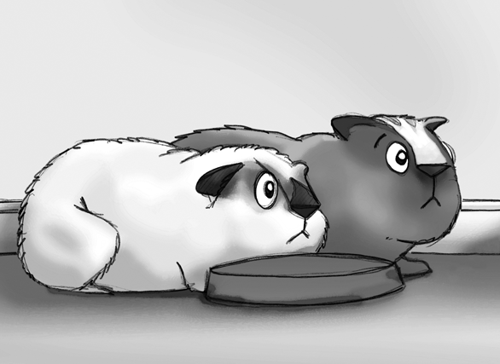 | It’s Holly.  It’s a box.  Oh, Fluff …
/ 3

Reading
A birdhouse
1. It’s Saturday. Olivia and her dad are in the garden. They are busy.
There’s wood and there’s a ladder. Dave is there too.

2. Olivia’s dad is on the ladder. The birdhouse is ready!
Olivia: Oh, it’s cool!

3. Dave is on the ladder. There’s a funny noise. What is it?

4. Miaow! Sid, Dave’s cat, is in the birdhouse. Oh no!

 |  | 10 | Read the story. Match each part (1–4) with the right picture. Write the  numbers 1–4 in the right boxes. Be careful: Two pictures are wrong.
Lies die Geschichte. Finde für jeden Teil (1–4) das richtige Bild. Schreibe die
Zahlen 1–4 in die richtigen Kästchen. Achtung: Zwei Bilder sind falsch.

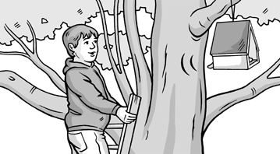 |  |  |  | 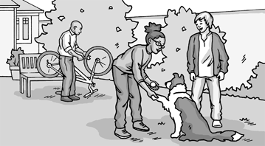
Part: |  |  |  | Part:
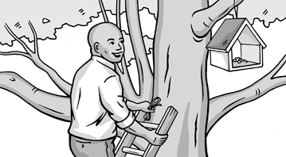 |  |  |  | 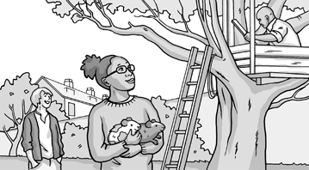
Part: |  |  |  | Part:
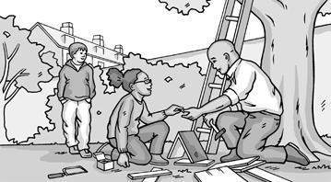 |  |  |  | 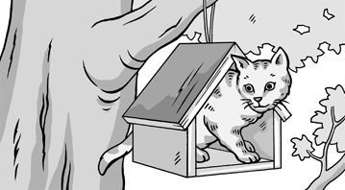
Part: |  |  |  | Part:

/ 4

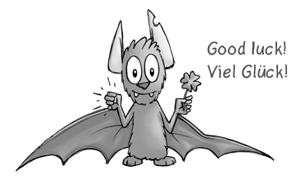

_____________ / 53 points mark: ___________________

